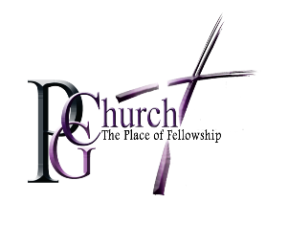
The Cathedral at Pleasant Grove
Bishop Courtney A. Jones, Lead Servant

I _______________________________________________
Pledge in the amount of ☐$500 ☐ $1000 ☐ $1500 ☐ Other____________
toward the $50,000 Capital Campaign for 2019 to be paid in full on or before September 29, 2019.

Signature_______________________ ____ Date __________________________
Best Contact Number___________________________

Thank you for your partnership!

“For God so loved the world that he gave his one and only son, that whoever believes in him shall not perish but have eternal life. John 3:16

